Homework 2: Data structures

By Vladimir Hardy

GitHub link with the most up-to-date code and full requirements <https://github.com/Spexon/LinkedLists>

**Requirements:**

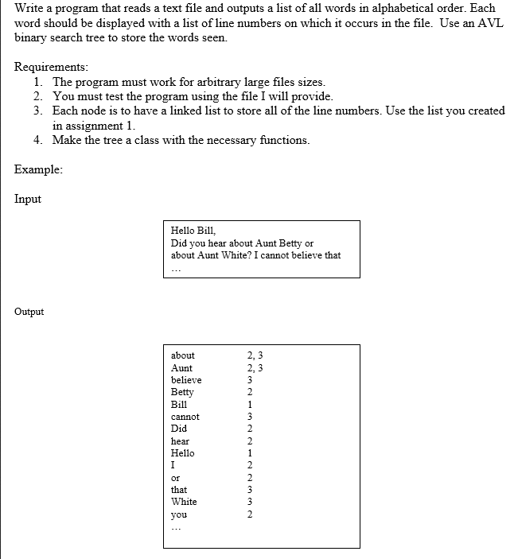

**Description:**

I approached this problem by first doing plenty of AVL tree graphing on paper to practice my understanding behind the logic. Then I created a new class for this algorithm and followed some of the code provided in class when explaining the AVL tree algorithm. This was when I encountered my first problem, and to this day I still do not fully understand why it occurs. When I would test my program, I would occasionally get errors of access denial, and wouldn’t be able to run my code until I did a fresh reboot (perhaps because my pointers were pointing somewhere they shouldn’t be). This issue greatly halted my progression on the assignment, and as a result I was unable to complete the majority of it. I would use the debugger and discovered that there were some segmentation fault errors occurring in my code. Here is the output of my partly sorted list (the sorting algorithm couldn’t finish because the pointers would never know when they reached the end of the linked list). The AVL tree would partially work, however I couldn’t find the time to implement it into the code, I used a whiteboard to follow along with my algorithm and it did not seem to work the same way as it was presented in class.

